1. 2 RAM
2. **Ram** is the **voilatile [Temporary]** storage for data and instructions. It is hold a data and instruction when you are using application, os [operating system].
3. 4
4. **GPU [ Graphics Processing Unit ]** is using for Graphic designing , video editing and AI.
5. True
6. True
7. True
8. **SSD [ Solid State Drive ]** is often using drive now days also it is faster then **HDD [Hard Disk Drives ]**.SSd storage capacities rang 120GB to 4TB and HDD storage capicities rang 250 GB to 14 TB.
9. The **BIOS [Basic Input Output System]** in a computer is a firmware that initializes hardware components and starts the operating system.Additionally, chack hardware components like RAM, CPU automatically through POST [POWER-ON SELF-TEST].
10. There are so many input components in computer like Keyboard, Mouse, Joy Stick, Light Pen, Track Ball, Scanner and so on. In that i declare Keyboard :- A primary input device that allows users to enter text, commands, and function keys to interact with the computer. Mouse :- A pointing device used to control the on-screen cursor. It enables users to select, drag, and click items. Scanner :- A device that converts physical documents or images into digital format.
11. 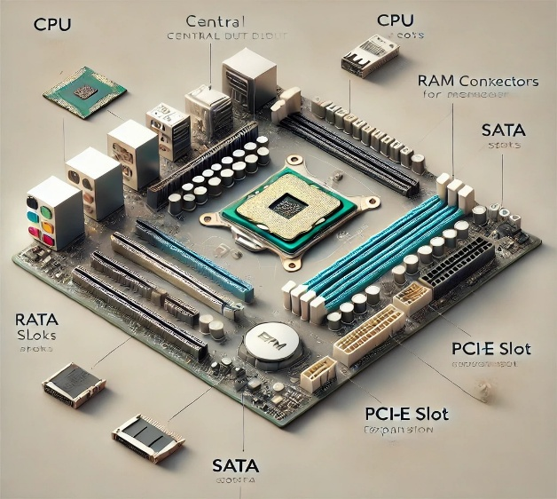  
     **Component Descriptions:**
12. **CPU (Central Processing Unit)** – The main processor, located in a square socket, usually with a heatsink or fan.
13. **RAM Slots** – Long, narrow slots (typically 2–4) where RAM sticks are installed.
14. **SATA Connectors** – Small L-shaped ports used for connecting storage devices like SSDs and HDDs.
15. The **PCI-E (Peripheral Component Interconnect Express) slot** is an expansion slot on a motherboard used to connect high-speed hardware components.
16. 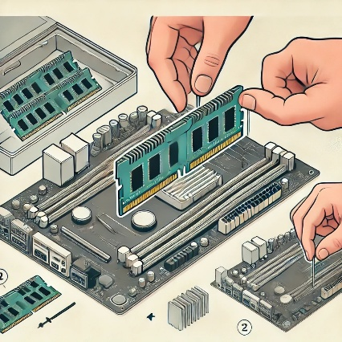

**Step 1: Gather Your Tools**

* A **Philips screwdriver**
* An **anti-static wrist strap**.

* **Step 2: Turn off power supply after that Open the Case**
* **Shut down** the computer and unplug the power cable.
* **Open the side panel** of the case using a screwdriver .
* **Step 3: Find the RAM Slots**
* Find the **RAM slots** on the motherboard.
* The slots are long and narrow, typically near the CPU.
* **Step 4: Insert the RAM Module**
* **Unlock the clips** on both sides of the RAM slot.
* Align the RAM module with the slot – the notch should match the ridge in the slot.
* Double-check that the RAM is **seated properly and secured** by the clips.
* Close the computer case and **reconnect power cables**.
* **Last of this process**
* **Step 6: Power On & Confirm RAM Installation**
* Turn on the computer and access the BIOS/UEFI to check the detected RAM.
* If the RAM is not detected, power down and reseat the module.
* **Section 5**:- Eassay
* In computer so many component is important. In that case i declare most significant part is cooling system. Cooling is essential in a computer system to maintain optimal performance and prevent hardware damage. When components such as the **CPU, GPU, and power supply** generate heat, effective cooling mechanisms are required to **dissipate heat** and maintain system stability. Additionally, i introduce you some importants of cooling such as Prevents Overheating, Enhances Performance, Keeps the engine running smoothly, Extends Hardware Lifespan and Improves System Stability. Here, I explain Prevents Overheating is the primary function is to dissipate heat generated by the engine's internal combustion process, preventing overheating and potential damage to engine components. In addition, it is more importance of maintaing. If Regular maintenance, including checking coolant level, inspecting hoses and belts, and ensuring the radiator is clean, it will crucial for preventing overheating and extending the engine's lifespan. A properly functioning cooling system is crucial for maintaining system stability by preventing overheating, which can lead to performance issues, component damage, and even system crashes. There are few cooling methods and efforts. Here, Air cooling, liquid cooling, thermal paste application, passive cooling. A conductive paste applied between the CPU/GPU and heatsink to improve heat transfer. Thermal paste fills these gaps, allowing for better contact and efficient heat dissipation. Instance, ARCTIC's MX-4 thermal paste is composed of microparticles which fill these cavities. In closure, Proper cooling is critical for a computer’s performance, stability, and longevity. Air cooling is sufficient for most users, while liquid cooling is ideal for high-performance systems. More advanced methods like immersion cooling are primarily used in specialized applications. Choosing the right cooling solution depends on usage, budget, and system requirements.